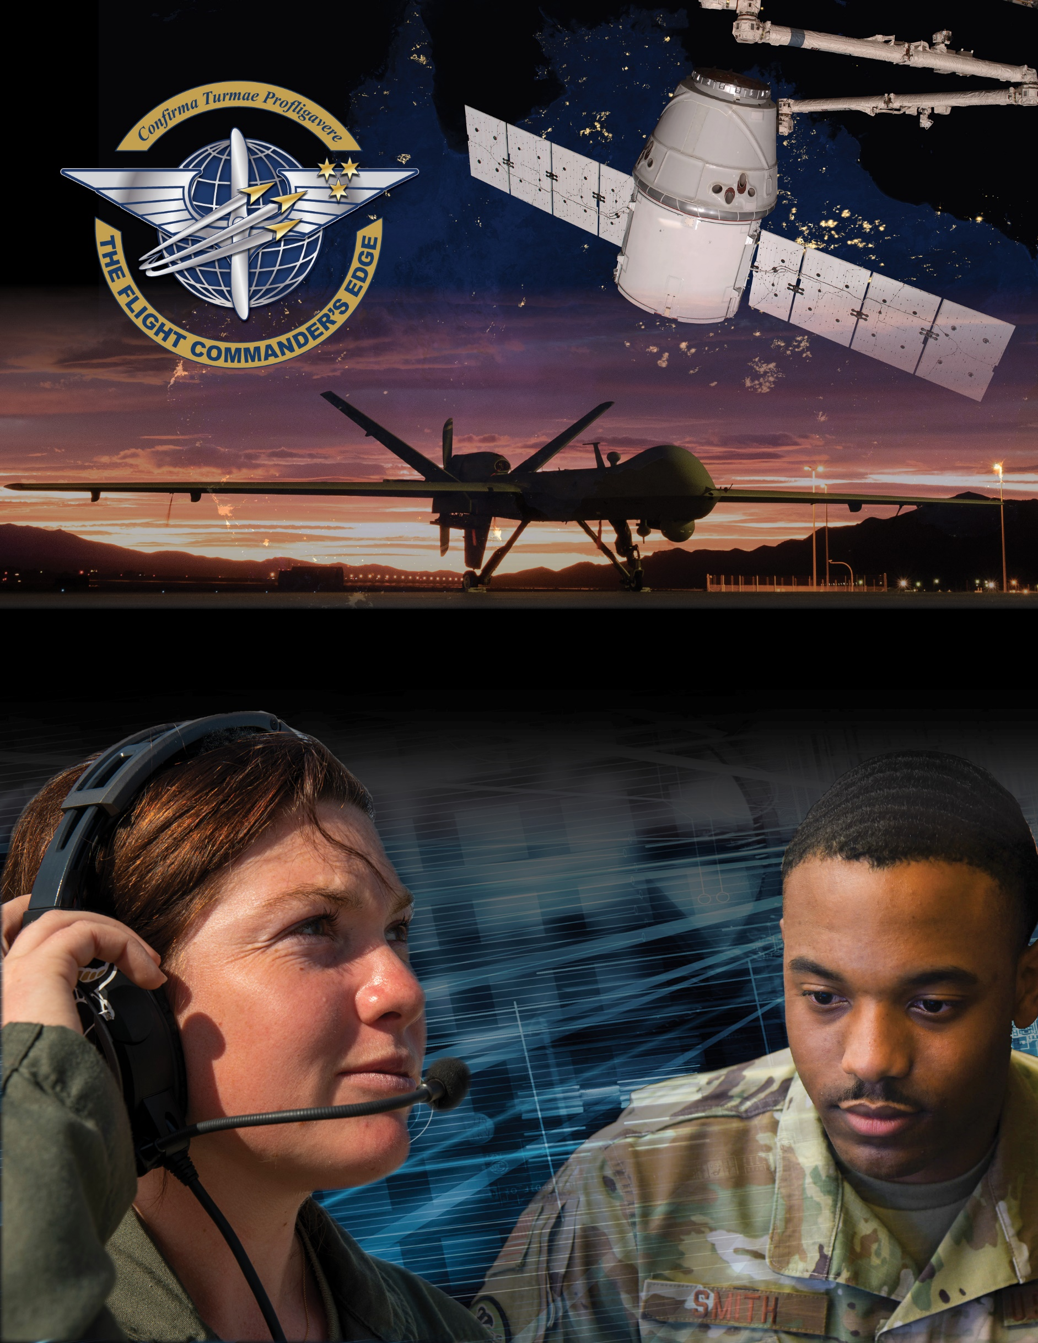

**Lesson Guide**



**Time and Meeting Management**

***14 April 2025***

**Time and Meeting Management**

### Purpose

This lesson guide is designed to support the local development of Flight Commander Leadership Course materials. Selected facilitators should use this guide as they prepare presentation materials. For more information on how lessons are structured, or how to use them in the course, see the ***Course Director’s Handbook*** or online Facilitator Resources.

### Scope

Being able to effectively manage one’s time is a key skill in the life of a Flight Commander. Juggling the various duties required of this role necessitates a need to delegate authority for certain tasks to focus your time on other responsibilities required of you. Time is a precious resource and, like manning or money, should not be wasted or carelessly spent.

As a Flight Commander, your time is limited and must be divided appropriately so as not to be consumed with any subset of tasks. Delegation of effort and authority will enable you to focus your time in other areas while still maintaining situational awareness on the tasks for which you are responsible. Leading a team also requires you to keep people working together towards a common goal and meetings are a way to build unity of effort. However, an inefficient or disorganized meeting will waste both your time and the time of your team.

### Recommended Objectives

By the end of this lesson, the participant should be able to:

1. Discuss how to effectively manage your time as a Flight Commander.
2. Understand delegation and the purpose and responsibilities associated with it.
3. Outline considerations for conducting an effective meeting.

### Recommended POC / Presenter

* Squadron-level leader (DO, CC or equivalent)

### Recommended Length:

* 30 minutes (inclusive of questions)

### Recommended Approach

* Present informational slides with Q & A

### Lesson Connections

* **Prioritization-**Most prioritized efforts require time, a finite resource. Flight Commanders must manage their time and their team’s time (including meetings) to meet priorities optimally.
* **Conflict Management-**Disagreement may arise on how team members should spend their time, or on topics in a meeting. An effective meeting organizer must know how to address such disagreement and move forward.

### Additional Discussion

It is important to recognize that delegation is more than simply having someone else complete a task for you; you must delegate the authority for them to make decisions associated with that task in line with your vision.

Flight Commanders should recognize that the amount of time and effort spent on accomplishing mission tasks can leave little time for developing self and others. You must be purposeful about allotting such time and consider what development efforts can be pursued during duty hours.